**Recipe Publishing System**

   
 

Submitted by: DesignDons

Submitted to: Jin Li

ICET Department,

School of Engineering Technology and Applied Science

Progress Campus, Block A

Centennial College

Discipline:   Software Engineering 

Due Date:    December 15, 2023

# Declaration of Sole Authorship

We, Harjit Singh Gill, Ling Lin, Rahul Garg, Ashutosh Kansal, Meskhat Hossain, confirm that this work submitted for assessment is our own and is expressed in our own words. Any uses made within it of the works of any other author, in any form (ideas, equations, figures, texts, tables, programs), are properly acknowledged at the point of use. A list of the references used is included.

Signed:   Harjit Singh Gill, 301258289 (Software Engineering Technician)

     Ling Lin, 301292283 (Software Engineering Technician)

     Rahul Garg, 301241213 (Software Engineering Technician)

     Meskhat Hossain, 301138382 (Software Engineering Technician)

     Ashutosh Kansal, 301233980 (Software Engineering Technician)

Date: September 15, 2023

# Abstract

 The Traditional Recipe Publishing System (TR) is a proposal for the development of an online platform called "Yummy Recipes" aimed at modernizing and streamlining the sharing of family recipes. In today's digital age, the traditional method of sharing recipes via phone calls and handwritten notes has become inefficient and prone to miscommunication. This proposal acknowledges the sentimental value of traditional recipe sharing but highlights the need for a more accessible and efficient solution.

The significance of this proposal lies in its mission to revolutionize how culinary traditions are shared and celebrated. It addresses the technical problem of inefficient recipe sharing within families and aims to create a user-friendly online platform where individuals and families can easily preserve and share their culinary expertise. By fostering a community of food lovers and promoting culinary diversity, "Yummy Recipes" seeks to enhance the accessibility of cherished family recipes.

To address these challenges and achieve its objectives, the proposal outlines the scope of the project, including website development with key features. It also sets specific goals, such as increasing recipe sharing by 20% compared to traditional methods and maintaining a high user satisfaction rating. Overall, this proposal encourages the development of an innovative platform that will make it easier for people to share, discover, and explore a diverse range of family recipes in the digital age.

**Table of Contents**

**Declaration of Sole Authorship** **2**

**Abstract** **3**

**List of Figures** **6**

**List of Tables** **7**

**1.0 INTRODUCTION** **8**

**2.0 METHODOLOGY AND RESULTS**11

2.1 Literature Review 11

2.2 Proposed Solution 14

2.3 User Role Modelling 15

2.3.1 Brainstorm and Group 15

2.3.2 Consolidated User Roles 17

2.3.3 Description of User Roles and Persona 18

2.3.4 Additional Documentation 21

2.4 Release 1.0 22

2.4.1  User Stories 22

2.4.2  Additional Documentation 25

2.4.3  Release Plan 1.0 26

2.4.4  Iteration Plan (Release 1.0) 30

2.4.5 Additional Documentation 40

2.4.6  Progress Monitoring 41

2.4.7  Acceptance Tests for Release 1.0 42

**3.0 CONCLUSIONS**52

**4.0 RECOMMENDATIONS**53

**CREDITS, LICENSE, AND REFERENCES**54

Credits 54

License 55

References 55

**APPENDIX A (DESIGN DOCUMENT)**56

**APPENDIX B (TEST PLAN)**61

1.0 Introduction 61

1.0.1   Goals 61

1.0.2   Assumptions 61

1.0.3   Risks And Assets 61

Describe the elements that might positively influence testing on the project. 36

2.0 Scope 62

2.0.1   Features To Be Tested 62

2.0.2   Features Not To Be Tested 68

3.0 Testing Procedures 69

3.0.1   Test Objectives 69

3.0.2   Types Of Testing 71

3.0.2.1   Unit Testing 72

3.0.2.2   Integration Testing 72

3.0.2.3   Acceptance Testing 72

3.0.2.4   Stress Testing 72

3.0.2.5   Performance Testing 73

3.0.3   Testing Tools 73

4.0 Schedule and Deliverables 74

**APPENDIX C (END-USER & ADMINISTRATOR MANUALS)**76

**APPENDIX D (PROGRESS MONITORING)**76

# List of Figures

Figure 1: Organizing the user role cards on a table [1]. 14

Figure 2: The consolidated role cards [1]. 16

Figure 3: Example of a “consolidated” low-fidelity prototype. Note that each “individual” low-fidelity prototype is developed for each user role [1]. 17

Figure 4: A story with notes providing additional detail [1]. 22

Figure 5: The revised front of a story card with only the story and questions to be discussed [1]. 23

Figure 6: Details that imply test cases are separated from the story itself. Here they are shown on the back of the story card [1]. 23

Figure 7: An example of a constraint story card [1]. 23

Figure 8: Possible electronic representation of a physical story card. 23

Figure 9: Iteration burndown chart for data from Table 5. 24

Figure 10: Low-fidelity prototype. 25

Figure 11: Iteration 1 Burndown Chart 33

Figure 12: Iteration 2 Burndown Chart 38

Figure 13: Low-Fidelity Prototype 56

Figure 14: Home Page Wireframe 57

Figure 15: Submit Recipe Page Wireframe 58

Figure 16: Login Page Wireframe 58

Figure 17: Registration Pae Wireframe 59

Figure 18: Recipe Details Page Wireframe 60

Figure 19: Home Page Screenshot 1 79

Figure 20: Home Page Screenshot 2 80

Figure 21: About Us Page Screenshot 1 82

Figure 22: About Us Page Screenshot 2 84

Figure 23: Contact Us Screenshot 86

Figure 24: Submit Recipe Screenshot 87

Figure 25: Login Page Screenshot 88

Figure 26: Register Page Screenshot 89

Figure 27: Search Results Screenshot 90

Figure 28: Recipe Details page Screenshot

Figure 29: Iteration 2 Burndown Chart 91

# List of Tables

Table 1: The Must-Have stories for Release 1 [1]. 24

Table 2: The Should-Have stories for Release 1 [1]. 24

Table 3: Release Plan Iteration 1 26

Table 4: Release Plan Iteration 2 27

Table 5: Release Plan Iteration 3 27

Table 6: Beginning and ending date for each iteration 29

Table 7: Iteration 1 Story 1 Disaggregation 30

Table 8: Iteration 1 Story 2 Disaggregation 30

Table 9: Iteration 1 Story 3 Disaggregation 31

Table 10: Iteration 1 Story 4 Disaggregation 31

Table 11: Iteration 1 Story 5 Disaggregation 32

Table 12: Iteration 1 Story 6 Disaggregation 32

Table 13: Iteration 1Story Points Chart 33

Table 14: Iteration 2 Story 1 Disaggregation 34

Table 15: Iteration 2 Story 2 Disaggregation 34

Table 16: Iteration 2 Story 3 Disaggregation 35

Table 17: Iteration 2 Story 4 Disaggregation 36

Table 18: Iteration 2 Story 5 Disaggregation 36

Table 19: Iteration 2 Story 6 Disaggregation 37

Table 20: Iteration 2 Story Points Chart

Table 21: Acceptance Tests for Release 1 37

Table 22: Schedule of Tasks 50

Table 23: List of Deliverables 75

Table 24: Progress Monitoring Table 91

# 1.0 INTRODUCTION

# Introduction:

# The traditional method of sharing family recipes, often through phone calls or handwritten notes, has long been a cherished tradition. However, in today's fast-paced digital age, this approach presents several challenges, including the risk of misunderstandings, lost details, and the difficulty of preserving these culinary treasures for future generations. In response to this evolving landscape and the need for a more efficient and accessible solution, we are thrilled to present our proposal for the "Yummy Recipes" project.

# The Technical Problem:

# The technical problem at hand is the inefficiency and limitations of the traditional phone-based method of sharing family recipes. While this approach holds sentimental value, it no longer aligns with the demands of the digital era. Phone-based recipe sharing is prone to miscommunication, and the details of beloved recipes can easily be lost or forgotten. Moreover, the lack of a centralized platform makes it challenging for culinary enthusiasts to access and explore a diverse range of family recipes conveniently.

# Why the Work Was Undertaken:

# The work described in this proposal was undertaken to address the technical problem of inefficient recipe sharing within families. Our objective is to revolutionize the way individuals and families share their culinary expertise by creating a user-friendly online platform, "Yummy Recipes," dedicated to preserving and celebrating family recipes. This platform aims to bring together a community of food lovers, making it easier for them to share, discover, and explore a rich tapestry of culinary traditions.

# Scope of the Report and Objectives:

# The scope of this report encompasses the entire Yummy Recipes project, from its conceptualization to its successful implementation. It includes the development of a fully functional website with user authentication, recipe management, search functionality, cuisine categorization, and features such as the display of the latest recipes and a random recipe picker. However, certain elements are excluded from the initial scope, such as the development of mobile applications, monetization features, localized versions, and extensive user support services. Our primary objective is to enhance the accessibility of cherished family recipes by offering a user-friendly online platform. We aim to increase recipe sharing by 20% compared to the traditional method within the first year, foster a community of at least 10,000 active users, streamline recipe sharing with 30,000 uploaded recipes in the first six months, promote culinary diversity, and maintain a user satisfaction rating of at least 4.5 out of 5. These objectives align with our mission to revolutionize how culinary traditions are shared and celebrated.

# During this project, we anticipate encountering unique challenges related to user engagement, platform performance, and the seamless integration of various features. To address these challenges, we will adopt innovative approaches and methodologies, ensuring that Yummy Recipes becomes the go-to platform for preserving and sharing family recipes in the digital age.

# 2.0 METHODOLOGY AND RESULTS

## 2.1 Literature Review

**Existing Solutions to Recipe Sharing Challenges**

Several solutions exist for sharing recipes, ranging from traditional methods to modern digital platforms. Here, we review some of these solutions, highlighting their strengths and weaknesses:

**Traditional Phone-Based Sharing:**

**Strengths:**

* Holds sentimental value and a personal touch.
* Direct communication for recipe details.
* An established method within families.

**Weaknesses:**

* Prone to misunderstandings and errors.
* Difficulty in preserving recipes for future generations.
* Inefficient for sharing with a broader community.

**Recipe Books and Handwritten Notes:**

**Strengths:**

* Tangible and easily accessible.
* Personalized and often cherished as family heirlooms.

**Weaknesses:**

* Limited distribution and accessibility.
* Vulnerable to damage, loss, or misplacement.
* Not easily shareable with a wider audience.

**Online Recipe Blogs and Websites:**

**Strengths:**

* Wide accessibility and availability.
* User-generated content and community engagement.
* Diverse recipe collections.

**Weaknesses:**

* Lack of standardization in recipe format.
* Limited control over recipe privacy.
* Often cluttered with ads and unrelated content.

**Recipe Sharing Apps:**

**Strengths:**

* User-friendly interfaces.
* Recipe categorization and search features.
* Social sharing and community engagement.

**Weaknesses:**

* Limited control over data privacy.
* Dependent on app store restrictions.
* May require downloads and updates.

## 2.2 Proposed Solution

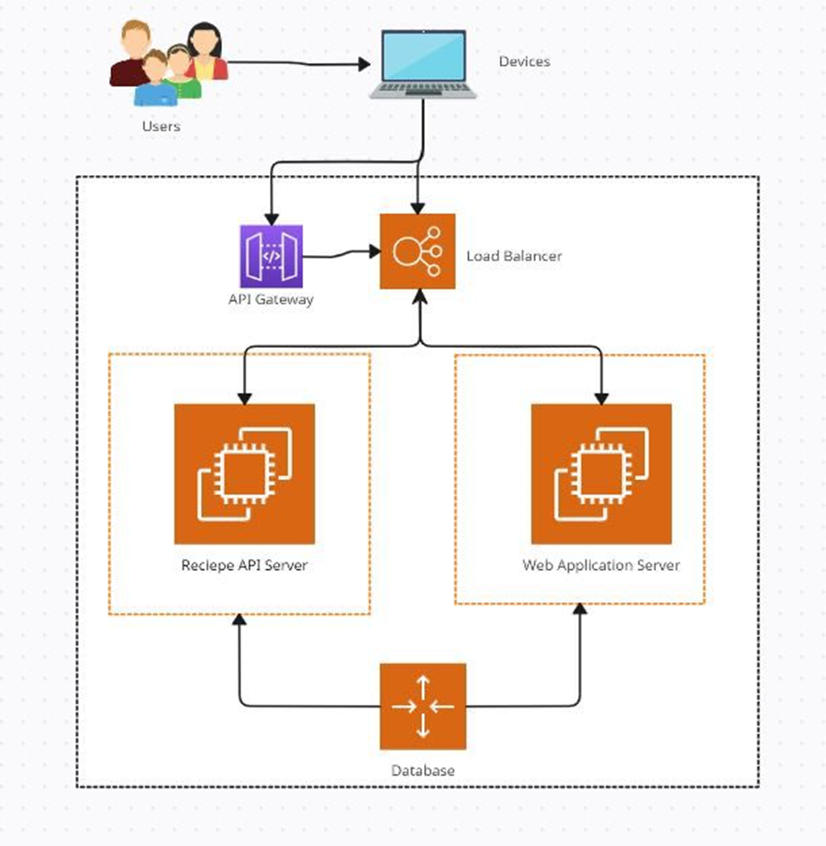

Figure 1: Proposed Solution.

**Users**: Your platform is designed to be user-centric, focusing on the community of food lovers and family members eager to share and preserve their recipes.

**Devices**: Accessibility through various devices ensures that users can interact with "Yummy Recipes" whether they are at home or on the go, making recipe sharing convenient and adaptable to modern lifestyles.

**API Gateway**: Acts as the orchestrator for all the incoming traffic, ensuring secure and efficient access to your platform's services, such as recipe uploads, searches, and user authentication.

**Load Balancer:** As your user base grows towards the 10,000 active users goal, the Load Balancer will be crucial in managing traffic and maintaining platform performance.

**Recipe API Server:** This specialized server could handle all recipe-related data processing, from uploading new recipes to categorizing them and supporting search functionalities.

**Web Application Server**: This server can manage the user interface and experience, ensuring that the website is responsive, intuitive, and visually appealing to keep user satisfaction ratings high.

**Database:** A robust database is necessary to store the 30,000 recipes you aim to collect in the first six months, as well as user profiles and activity data, with secure backup and recovery procedures in place.

## 2.3 User Role Modelling

### 2.3.1 Brainstorm and Group

**Group Members:**

* Harjit Singh Gill, 301258289
* Ling Lin, 301292283
* Rahul Garg, 301241213
* Meskhat Hossain, 301138382
* Ashutosh Kansal, 301233980

**Initial set of user roles:**

* Guest User
* Registered User
* Recipe Contributor
* Recipe Moderator
* Administrator
* Superuser
* Home Cooks
* Professional Chefs
* Food Bloggers and Influencers
* Food Enthusiasts
* Recipe Collectors
* Event Planners
* Parents and Caregivers
* Cooking Educators

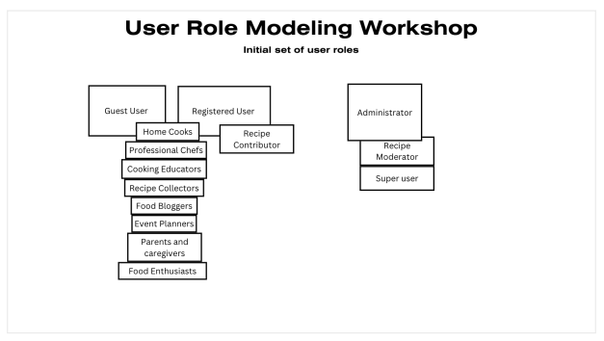

Figure 2: Organizing the user role cards on a table.

### 2.3.2 Consolidated User Roles

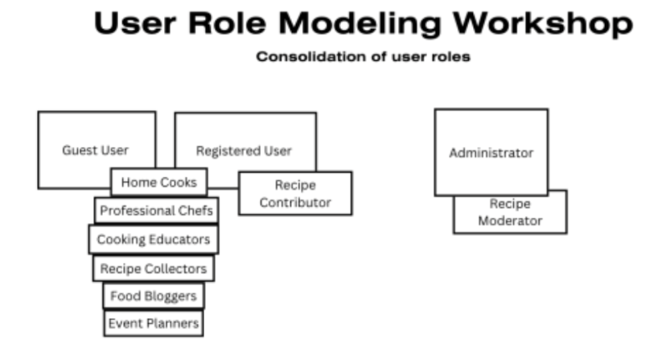

Figure 3: The consolidated role cards.

**Key Changes:**

We merged the "Parents and Caregivers" and "Food Enthusiasts" roles into "Home Cooks," recognizing that their platform usage patterns were sufficiently similar. This simplification reduces complexity without sacrificing the inclusivity of our user base.

The "Super user" role was absorbed into the broader "Administrator" category. This decision was twofold: to tighten security by limiting the number of roles with extensive system access and to provide a more concentrated administrative structure for our team to manage.

We identified that all registered users who contribute content, regardless of their culinary expertise or professional background, share common functionalities. Thus, we introduced a singular "Recipe Contributor" role, which encapsulates this shared purpose and promotes a sense of community and contribution across the platform.

**Rationale for Consolidation:**

The consolidation process aimed to strike a balance between specificity and usability. While our initial model was detailed, it became apparent that a more streamlined approach would serve us better in design and implementation.

We were mindful of role overlap, which could dilute the user experience and complicate backend management. By merging roles with overlapping functionalities, we can offer a more cohesive and intuitive user experience.

Our focus sharpened towards active user engagement. By highlighting the "Recipe Contributor" role, we aim to foster an environment where sharing and interaction are at the forefront, driving content generation and platform growth

### 2.3.3 Description of User Roles and Persona

**Administrator**

Frequency of Use: Regularly

Expertise: High

Computer and Software Proficiency: High

Goal: Overseeing the platform’s functionalities, resolving issues, ensuring smooth operations

**Recipe Moderator**

Frequency of Use: Regularly

Expertise: Moderate to High

Computer and Software Proficiency: Moderate to High

Goal: Ensuring the quality and accuracy of shared recipes, maintaining platform standards, actively monitoring and curating recipes.

**Guest User**

Frequency of Use: Infrequent

Expertise: Beginner to expertise level

Computer and Software Proficiency: Limited familiarity with Yummy Recipes. Goal: Browsing recipes, getting a feel for the platform, and exploring without commitment.

**Home Cooks**

Frequency of Use: 1-2 times a week

Expertise: intermediate to expertise level

Computer and Software Proficiency: Good familiarity with Yummy Recipes.

Goal: Sharing their family recipes, finding new recipes, connecting with culinary community

**Professional Chefs**

Frequency of Use: Occasional

Expertise: High

Computer and Software Proficiency: Moderate to high familiarity

Goal: Exploring new ideas or sharing signature dishes, Sharing expertise, networking with other chefs, and showcasing their creations

**Cooking Educators**

Frequency of Use: Regularly

Expertise: high

Computer and Software Proficiency: high familiarity with Yummy Recipes

Goal: Sharing educational content, accessing a repository of diverse recipes for teaching

**Recipe Collectors**

 Frequency of Use: 1-2 times a week

Expertise: Moderate to high level

Computer and Software Proficiency: good familiarity with Yummy recipes

Goal: Safeguarding and organizing family recipes, occasional sharing with close contacts.

**Food Bloggers**

Frequency of Use: Regularly

Expertise: Moderate to high

Computer and Software Proficiency: High familiarity

Goal: Content creation, sharing recipes for their audience, increasing engagement, and gaining followers

**Event Planners**

Frequency of Use: Regularly

Expertise: High

Computer and Software Proficiency: Great familiarity with yummy recipes

Goal: Finding suitable recipes for events, organizing menus, and ensuring variety.

**Registered User**

Frequency of Use: Regularly

Expertise: Moderate to high

Computer and Software Proficiency: Good familiarity

Goal: Accessing personalized features, saving favourite recipes, and actively participating in the community.

**Recipe Contributor**

Frequency of Use: Regularly

Expertise: High

Computer and Software Proficiency: Expert in using Yummy Recipes

Goal: Sharing their original recipes with the community, gaining recognition, building an audience.

### 2.3.4 Additional Documentation

<https://e.centennialcollege.ca/d2l/lms/dropbox/user/folders_history.d2l?db=672972&grpid=1046566&isprv=0&bp=0&ou=1010544>

## 2.4 Release 1.0

### 2.4.1 User Stories

The "Low Fidelity Prototype" document for "Yummy Recipes" is a structured guide illustrating the user journey within the platform. It captures the flow from initial engagement, such as guest viewing or account registration, to deeper interactions, including recipe submission and category browsing. The document addresses distinct user needs and showcases the system's responses to various actions, ensuring the platform is user-friendly for contributors and administrators. This prototype serves as a vital tool for developers and designers, laying out the blueprint for creating an intuitive and efficient user experience on the "Yummy Recipes" platform.

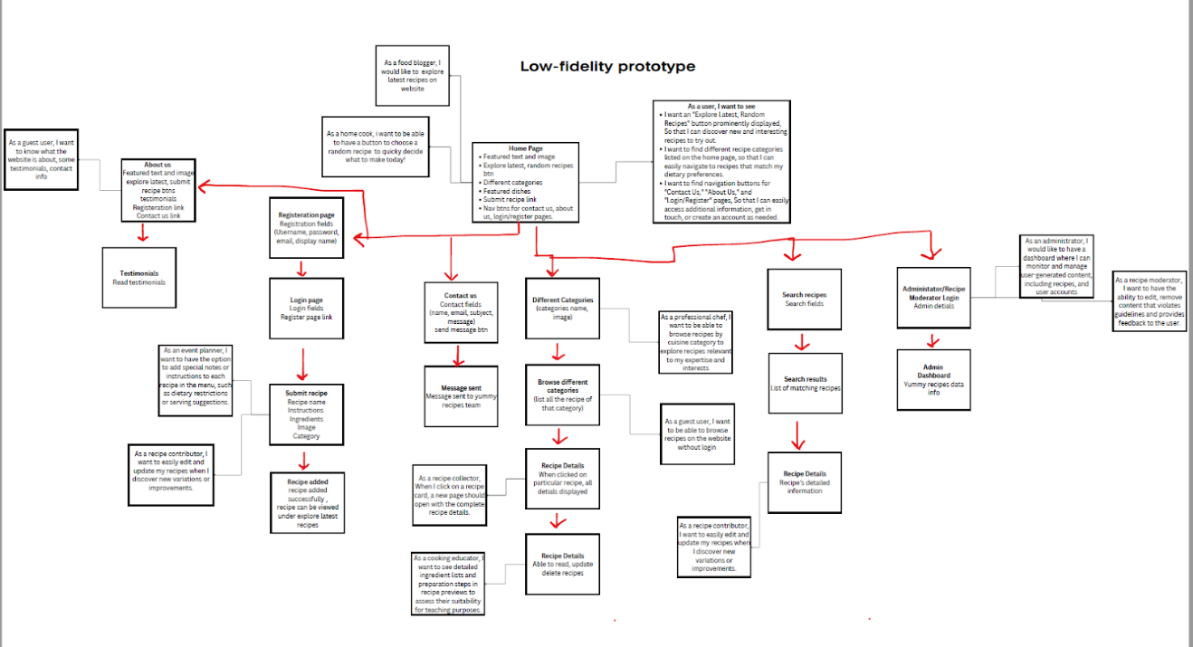

Figure 3: Example of a “consolidated” low-fidelity prototype.

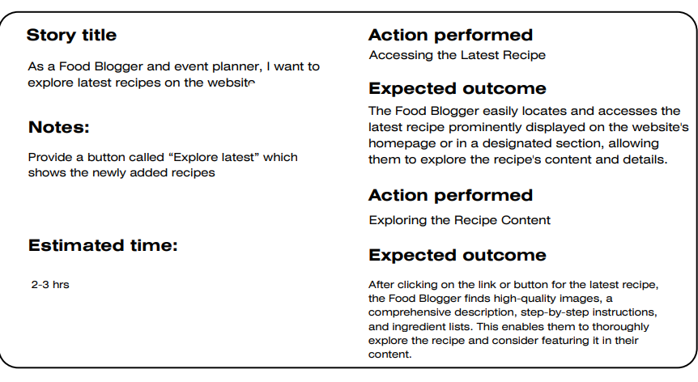

Figure 4: A story with notes providing additional detail.

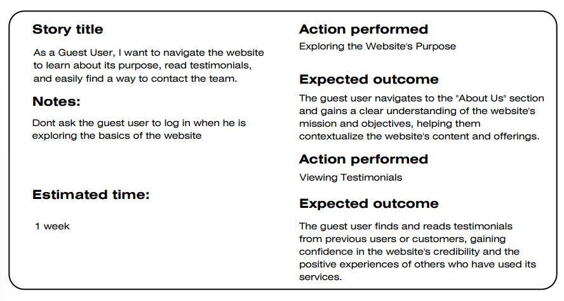

Figure 5:A story with notes providing additional detail.

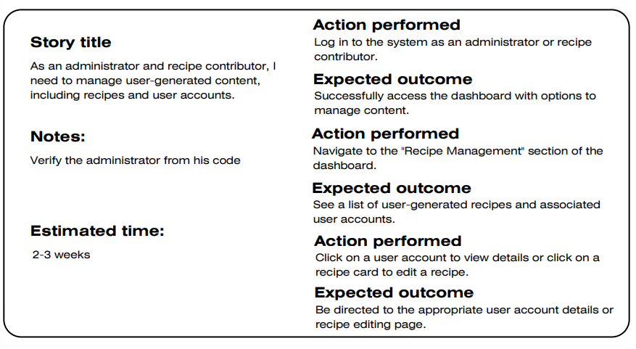

Figure 6: A story with notes providing additional detail.

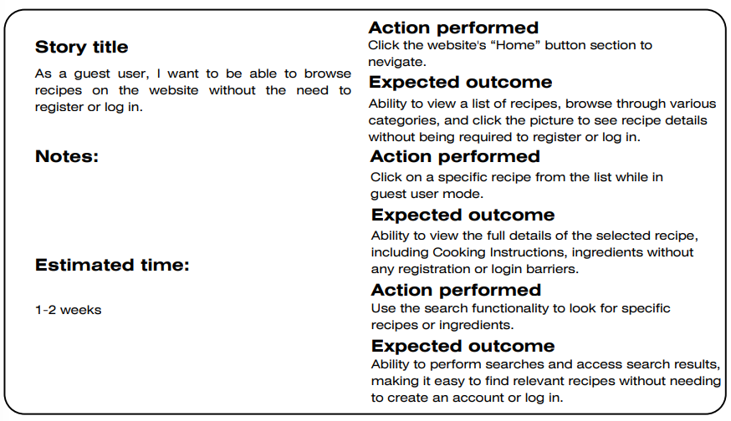

Figure 7: A story with notes providing additional detail.

|  |  |
| --- | --- |
| Ability to Write Special Notes in Recipe  Note: Will we accept Discover cards?  Note for UI: Don’t have a field for card type (it can be derived from the first two digits on the card)  Estimate: 2-3 weeks | Adding Special Notes to a Recipe  Expected outcome: The Event Planner accesses the menu management system and successfully adds customized special notes or instructions to a specific recipe. These notes can include dietary restrictions, allergy information, and serving suggestions tailored to that particular dish.  ...*<rest of the Tests follows>* |

Figure 8: Possible electronic representation of a physical story card.

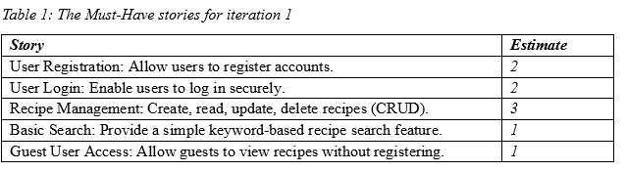

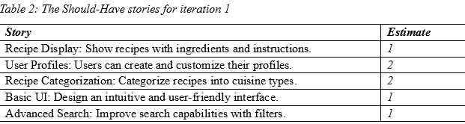

### 2.4.2  Additional Documentation

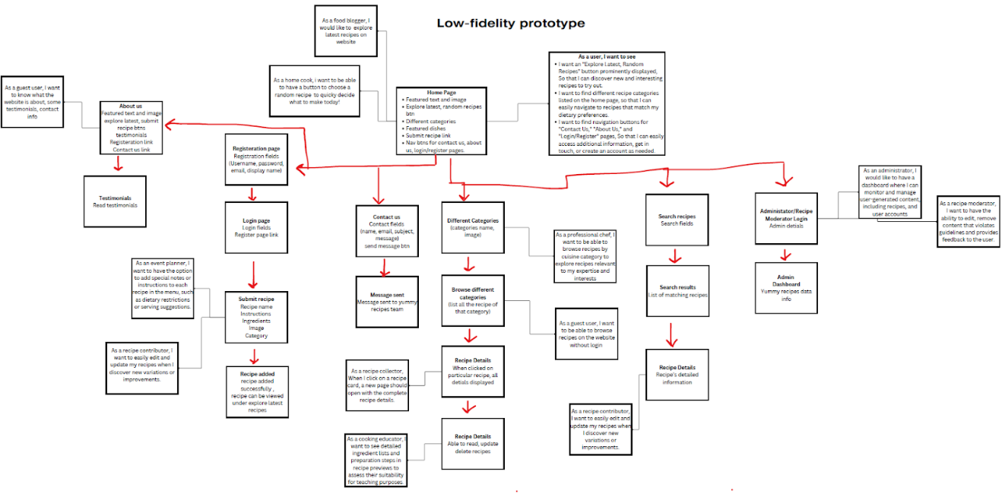

Figure 10: Low-fidelity prototype.

YouTube: <https://youtu.be/BGmDbhAd5js>

GitHub link: <https://github.com/harjitsinghgill8289/COMP231004Team6/tree/main/Meetings>

### 2.4.3  Release Plan 1.0

**Release 1**

**Iteration 1 (Nov 4)**

Theme: Core Functionality

Description: Implement essential features for recipe sharing, user registration, and recipe management.

**Interaction 2 (Nov 25):**

Theme: User Engagement and Interaction

Description: Enhance user experience with features like recipe categorization, viewing recipes without registration, and exploring recipes by cuisine.

**Iteration 3 (Dec 9):**

Theme: Recipe Improvements and Administration

Description: Allow recipe contributors to edit and manage their recipes, introduce random recipe suggestions, and provide admin tools for content moderation.

**Release Plan (Oct. 22, 2023)**

|  |
| --- |
| **Iteration 1** |
| User Registration: Allow users to register accounts. |
| User Login: Enable users to log in securely. |
| Recipe Management: Create, read, update, delete recipes (CRUD). |
| Basic Search: Provide a simple keyword-based recipe search feature. |
| Guest User Access: Allow guests to view recipes without registering. |
| Recipe Display: Show recipes with ingredients and instructions. |
| User Profiles: Users can create and customize their profiles. |

Table 3: Release Plan Iteration 1

|  |
| --- |
| **Iteration 2** |
| Recipe Navigation: Users can easily browse recipes. |
| Recipe Category Filters: Filter recipes by cuisine. |
| Guest User Experience: Ensure guests can explore seamlessly. |
| User Recipe Sharing: Enable users to share their recipes. |
| Recipe Recommendations: Suggest similar recipes. |
| Advanced UI Improvements: Enhance the interface for engagement. |
| Social Sharing Integration: Allow easy sharing on social media. |

Table 4: Release Plan Iteration 2

|  |
| --- |
| **Iteration 3** |
| Recipe Editing: Allow recipe contributors to edit recipes. |
| Random Recipe Generator: Suggest random recipes. |
| User Account Management: Admin can handle user accounts. |
| Admin Tools: Enhance content moderation and user management. |
| Recipe Data Validation: Validate recipe data and formatting. |
| Security Enhancements: Strengthen security measures. |

Table 5: Release Plan Iteration 3

**Priorities of the Must- and Should-Have Stories**

**Prioritize stories by ranking stories that are most important to the system (core features) to the least important to the system (non-distinguishing features).**

**1. Core Features:**

User Authentication System: Ensures secure access for all users and is fundamental to the platform.

Recipe Management: Core functionality allows users to create, read, update, and delete recipes.

Recipe Search Functionality: Enables users to find specific recipes efficiently, enhancing user experience.

Cuisine Categories: Organizes recipes, providing a structured way for users to explore different cuisines.

Latest Recipes Section: Displays the most recently added recipes, keeping the platform dynamic and engaging.

**2. Important but Not Core:**

Random Recipe Picker Button: Provides an engaging feature for users but not essential for basic functionality.

Ability to Write Special Notes in Recipe: Enhances user experience by adding detailed information but not critical for basic usage.

**3. Supporting Features:**

Administrator and Recipe Moderator Dashboard: Important for managing content but not crucial for general users.

Editing and Removing User-Generated Content: Essential for maintaining content quality but not a core user function.

Guest User Exploration: Important for new users but not as critical as core features for regular users.

In-Depth Recipe Previews for Teaching: Specific feature catering to a particular user group but not vital for the majority of users.

Browsing Recipes by Cuisine Category: Useful for specific user interests but not essential for all users.

**Beginning and ending date for each Iteration**

|  |  |  |  |
| --- | --- | --- | --- |
| **Iteration** | **Start Date** | **End Date** | **Themes** |
| Iteration 1 | Oct. 24, 2023 | Nov. 04, 2024 | Core Functionality |
| Iteration 2 | Nov. 05, 2024 | Nov. 25, 2024 | User Engagement and Interaction |
| Iteration 3 | Nov. 26, 2024 | Dec. 09, 2024 | Final Polish and Expansion |

Table 6: Beginning and ending date for each iteration

### 2.4.4 Iteration Plan (Release 1.0)

**Iteration 1 Story Disaggregation**

**Story 1:**

Rahul - As a Food Blogger and event planner, I want to explore the latest recipes on the website.

|  |  |  |  |
| --- | --- | --- | --- |
| **Task** | **Who** | **Estimate** | **Actual** |
| Create "Explore Latest" Button | Harjit Gill | 1 | N/A |
| Implement Backend Functionality | Ling Lin | 2 | N/A |
| Design Latest Recipe Section UI/UX | Meskhat Hossain | 2 | N/A |
| Integrate Latest Recipe Content | Rahul Garg | 2 | N/A |
| QA Testing and Bug Fixes | Ashutosh Kansal | 1 | N/A |

Table 7: Iteration 1 Story 1 Disaggregation

**Story 2:**

Rahul - Ability to Write Special Notes in Recipe.

|  |  |  |  |
| --- | --- | --- | --- |
| **Task** | **Who** | **Estimate** | **Actual** |
| Implement Special Notes Feature - Frontend | Harjit Gill | 1 | N/A |
| Implement Special Notes Feature - Backend | Ling Lin | 2 | N/A |
| Database Integration for Special Notes | Rahul Garg | 2 | N/A |
| UI/UX Design for Special Notes | Meskhat Hossain | 1 | N/A |
| QA Testing and Bug Fixes | Ashutosh Kansal | 1 | N/A |
| Implement Special Notes Feature - Frontend | Harjit Gill | 1 | N/A |

Table 8: Iteration 1 Story 2 Disaggregation

**Story 3:**

Rahul - As a Guest User, I want to navigate the website to learn about its purpose, read testimonials, and easily find a way to contact the team.

|  |  |  |  |
| --- | --- | --- | --- |
| **Task** | **Who** | **Estimate** | **Actual** |
| Design "About Us" Section UI/UX | Meskhat Hossain | 1 | N/A |
| Implement "About Us" Section - Frontend | Harjit Gill | 1 | N/A |
| Implement Testimonials Section - Frontend | Harjit Gill | 1 | N/A |

Table 9: Iteration 1 Story 3 Disaggregation

**Story 4:**

Harjit - As a home cook or recipe collector, I want to view complete recipe details.

|  |  |  |  |
| --- | --- | --- | --- |
| **Task** | **Who** | **Estimate** | **Actual** |
| Implement Recipe Card Click Functionality | Harjit Gill | 2 | N/A |
| Create Recipe Details Page UI/UX Design | Meskhat Hossain | 1 | N/A |
| Implement Recipe Details Page - Frontend | Harjit Gill | 2 | N/A |
| Backend Integration for Recipe Details | Ling Lin | 2 | N/A |
| Implement Add to Collection/Favorite Functionality | Harjit Gill | 2 | N/A |
| QA Testing and Bug Fixes | Ashutosh Kansal | 1 | N/A |
| Implement Recipe Card Click Functionality | Harjit Gill | 2 | N/A |

Table 10: Iteration 1 Story 4 Disaggregation

**Story 5:**

Harjit - As a recipe collector, I want a button which gives me random recipes to try for fun.

|  |  |  |  |
| --- | --- | --- | --- |
| **Task** | **Who** | **Estimate** | **Actual** |
| Design "Random Recipe" Button UI/UX | Meskhat Hossain | 1 | N/A |
| Implement "Random Recipe" Button - Frontend | Harjit Gill | 2 | N/A |
| Backend Logic for Selecting Random Recipe | Ling Lin | 2 | N/A |
| Integrate Random Recipe with Database | Rahul Garg | 2 | N/A |
| Implement Random Recipe Details Page - Frontend | Harjit Gill | 2 | N/A |
| QA Testing and Bug Fixes | Ashutosh Kansal | 1 | N/A |

Table 11: Iteration 1 Story 5 Disaggregation

**Story 6:**

Harjit - As an administrator and recipe contributor, I need to manage user-generated content, including recipes and user accounts.

|  |  |  |  |  |
| --- | --- | --- | --- | --- |
| **Task** |  | **Who** | **Estimate** | **Actual** |
| Implement Administrator and Contributor Login |  | Ling Lin | 2 | N/A |
| Create Dashboard UI/UX for Content Management |  | Meskhat Hossain | 1 | N/A |
| Implement Dashboard Functionality - Backend |  | Ling Lin | 2 | N/A |
| Implement Recipe Management Section - Frontend |  | Harjit Gill | 2 | N/A |
| Implement User Account Management - Frontend |  | Harjit Gill | 2 | N/A |
| Implement User Account Details Page - Frontend |  | Harjit Gill | 2 | N/A |
| Implement Recipe Editing Page - Frontend |  | Harjit Gill | 3 | N/A |
| QA Testing and Bug Fixes |  | Ashutosh Kansal | 1 | N/A |

Table 12: Iteration 1 Story 6 Disaggregation

**Iteration 1 burndown chart for data**

|  |  |
| --- | --- |
|  | Iteration 1 |
| Story Points at start of iteration | 71 |
| Completed during iteration | 56 |
| Changed estimates | 14 |
| Story Points from new stories | 76 |
| Story Points at end of iteration | 105 |

Table 13: Iteration 1 Story Points Chart

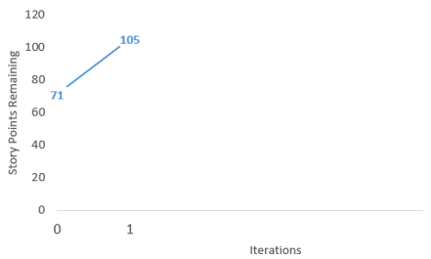

Figure 11: Iteration 1 Burndown Chart

**Iteration 2 Story Disaggregation**

**Story 1:**

Ling Lin - As a recipe contributor, I want to make improvements to my existing recipes.

|  |  |  |  |
| --- | --- | --- | --- |
| **Task** | **Who** | **Estimate** | **Actual** |
| Code User Authentication | Ling Lin | 2 | N/A |
| Code Dashboard with Recipe Management Options | Harjit Gill | 3 | N/A |
| Code "My Recipes" Section Screen | Meskhat Hossain | 2 | N/A |
| Code Recipe Selection and Loading Screen | Harjit Gill | 2 | N/A |
| Code Recipe Editing Interface Screen | Meskhat Hossain | 3 | N/A |
| Write and Tune SQL for Data Modification Logic | Rahul Garg | 2 | N/A |
| Save Recipe Changes to Database | Ling Lin | 2 | N/A |

 Table 14: Iteration 2 Story 1 Disaggregation

**Story 2:**

Ling Lin - As an administrator or a recipe moderator, I want to have access to a dashboard where I can monitor and manage user-generated content, including recipes and user accounts.

|  |  |  |  |
| --- | --- | --- | --- |
| **Task** | **Who** | **Estimate** | **Actual** |
| Code Admin/Moderator Authentication | Ling Lin | 2 | N/A |
| Dashboard Implementation for Content Management | Harjit Gill | 3 | N/A |
| Code "Review Recipes" Screen | Meskhat Hossain | 2 | N/A |
| Code "Manage User Accounts" Screen | Harjit Gill | 2 | N/A |
| Write and Tune SQL for Content Management Logic | Rahul Garg | 2 | N/A |

 Table 15: Iteration 2 Story 2 Disaggregation

**Story 3:**

Ling Lin - As an administrator or a recipe moderator, I want to have the ability to edit or remove content that violates guidelines and provide feedback to the user.

|  |  |  |  |
| --- | --- | --- | --- |
| **Task** | **Who** | **Estimate** | **Actual** |
| Code to Access Problematic Content | Harjit Gill | 2 | N/A |
| Write and Tune SQL to Delete Violating Content and Inform User | Rahul Garg | 3 | N/A |
| Code to Edit Content and Provide Feedback to User | Ling Lin | 4 | N/A |
| Code to Select Offending Content | Meskhat Hossain | 2 | N/A |
| Code Feedback Mechanism for Communication with Users | Harjit Gill | 3 | N/A |

 Table 16: Iteration 2 Story 3 Disaggregation

**Story 4:**

Hossain - As a guest user, I want to be able to browse recipes on the website without the need to register or log in.

|  |  |  |  |
| --- | --- | --- | --- |
| **Task** | **Who** | **Estimate** | **Actual** |
| Implement Homepage Navigation - Frontend | Harjit Gill | 1 | N/A |
| Implement Recipe List UI/UX Design | Meskhat Hossain | 1 | N/A |
| Implement Recipe List - Frontend | Harjit Gill | 2 | N/A |
| Implement Recipe Details UI/UX Design | Meskhat Hossain | 2 | N/A |
| Implement Recipe Details Page - Frontend | Harjit Gill | 2 | N/A |
| Implement Search Functionality - Frontend and Backend | Harjit Gill and Ling Lin | 3 | N/A |
| QA Testing and Bug Fixes | Ashutosh Kansal | 2 | N/A |

 Table 17: Iteration 2 Story 4 Disaggregation

**Story 5:**

Harjit - As a cooking educator, I would like to see In-Depth Recipe Previews for Teaching.

|  |  |  |  |
| --- | --- | --- | --- |
| **Task** | **Who** | **Estimate** | **Actual** |
| Design Recipe Preview UI/UX | Meskhat Hossain | 2 | N/A |
| Implement Recipe Preview - Frontend | Harjit Gill | 2 | N/A |
| Backend Integration for Recipe Preview | Ling Lin | 3 | N/A |
| Create Detailed Recipe Page UI/UX Design | Meskhat Hossain | 4 | N/A |
| Implement Detailed Recipe Page - Frontend | Harjit Gill | 2 | N/A |
| QA Testing and Bug Fixes | Ashutosh Kansal | 2 | N/A |

 Table 18: Iteration 2 Story 5 Disaggregation

**Story 6:**

Ling Lin - As a professional chef, wants to be able to browse recipes by cuisine category so that | can explore recipes relevant to my expertise and interests.

|  |  |  |  |
| --- | --- | --- | --- |
| **Task** | **Who** | **Estimate** | **Actual** |
| Code Cuisine Category List Screen | Harjit Gill | 2 | N/A |
| Code "Browse by Cuisine" Menu Option | Meskhat Hossain | 2 | N/A |
| Code Page for Curated Recipes by Cuisine | Harjit Gill | 2 | N/A |
| Write and Tune SQL for Recipe Details | Rahul Garg | 2 | N/A |
| Code Recipe Details Screen | Ashutosh Kansal | 2 | N/A |

 Table 19: Iteration 2 Story 6 Disaggregation

**Iteration 2 burndown chart for data**

|  |  |  |
| --- | --- | --- |
|  | Iteration 1 | Iteration 2 |
| Story Points at start of iteration | 71 | 105 |
| Completed during iteration | 56 | 85 |
| Changed estimates | 14 | 21 |
| Story Points from new stories | 76 | 0 |
| Story Points at end of iteration | 105 | 41 |

Table 20: Iteration 2 Story Points Chart

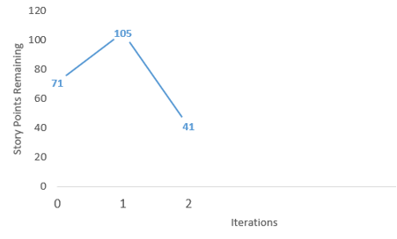

Figure 12: .Iteration 2 Burndown Chart

**Discussion**

The presented table summarises our project's development through Iterations 1 and 2, shining light on significant parts of our progress, estimates, and story points. Let us now get into further detail:

1. **The First Story Points:**

In Iteration 1, our project had 71 story points, which increased to 105 in Iteration 2. This expansion shows a bigger scope or the addition of more features as the project progressed.

2. **Worked on During Iteration:**

Iteration 1 saw the effective completion of 56 story points, demonstrating the team's remarkable commitment. Building on this momentum, Iteration 2 displayed even more efficiency, completing 85 story points. This rise indicates an improved ability to meet project objectives.

3. **Estimates Have Changed:**

The revised estimations demonstrate our team's adaptability and flexibility. 14 plot points were changed in Iteration 1, and this number increased to 21 in Iteration 2. Understanding the reasons for these variations is critical for improving our estimating procedures.

4. **Story Elements from Recent Stories:**

Iteration 1 introduced 76 new plot points, reflecting the project's fluid character. Iteration 2 does not feature any new story points, implying a probable requirement stabilisation or a concentrated effort on existing activities.

5. **Story Points at End of Iteration:**

The story points at the end of each iteration (105 in Iteration 1 and 41 in Iteration 2) highlight the evolving nature of our project. These figures serve as indicators of the work remaining and guide our planning for subsequent iterations.

6. **Overall Observations:**

A holistic view of the data reveals trends and patterns that warrant attention. Whether it's consistent overestimation, underestimation, or external factors influencing estimates, understanding these dynamics is vital for continuous improvement.

7. **Areas of Improvement:**

It's essential to identify areas where we excelled and those that may require attention. This could involve refining our estimation practices, addressing factors contributing to changed estimates, and ensuring a balanced approach to introducing new stories.

8. **Considerations for the Future:**

With the knowledge gained from Iterations 1 and 2, we are well-positioned to plan for the future. Considerations for improving our procedures and approaches should be included into future iterations to improve project outcomes.

Finally, this discussion gives a thorough examination of our project's trajectory, providing significant insights for the team's reflection and progress. Let us use these lessons learned to move our project forward in future iterations.

### 2.4.5 Additional Documentation

Iteration 1 Planning:

GitHub link: <https://github.com/harjitsinghgill8289/COMP231004Team6/tree/main/Meetings/Iteration1>

YouTube: <https://youtu.be/IMxhbj8YjO8>

Iteration 2 Planning:

GitHub link: <https://github.com/idalin6127/Iteration2.git>

YouTube: <https://youtu.be/PZBv-HfAjFY>

Iteration 2 progress monitoring report:

GitHub Link: <https://github.com/idalin6127/Iteration2>

Online Hosting Link: <https://yummmyrecipes.onrender.com/>

### 2.4.7  Acceptance Tests for Release 1.0

Table 4: Stories, acceptance tests, and contributors for Release 1.x (Green=Passed; Red=Failed).

|  |  |  |
| --- | --- | --- |
| **User Story Description** | **Acceptance Criteria/Test(s)** | **Contributing Developer(s)** |
| As a Food Blogger and event planner, I want to explore the latest recipes on the website. | Test with inputs: Click "Explore Latest" button | Ashutosh Kansal |
|  | Expected outcome: Latest recipes displayed prominently on homepage or in a designated section |  |
|  |  |  |
|  | Test with inputs: Click on the latest recipe | Harjit Singh Gill |
|  | Expected outcome: High-quality images, comprehensive recipe details |  |
|  |  |  |
| As an Event Planner, I want to be able to write special notes in a recipe. | Test with inputs: Add special notes to a recipe | Harjit Singh Gill, Ling Lin |
|  | Expected outcome: Successfully added notes to a recipe |  |
|  |  |  |
|  | Test with inputs: View menu management system | Meskhat Hossain |
|  | Expected outcome: Special notes displayed alongside recipes in the event menu |  |
|  |  |  |
| As a Guest User, I want to navigate the website to learn about its purpose, read testimonials, and easily find a way to contact the team. | Test with inputs: Explore "About Us" section | Ashutosh Kansal, Rahul Garg |
|  | Expected outcome: Clear understanding of website's mission and objectives |  |
|  |  |  |
|  | Test with inputs: View testimonials | Harjit Singh Gill |
|  | Expected outcome: Gain confidence in the website's credibility and positive user experiences |  |
|  |  |  |
| As an Administrator and recipe contributor, I need to manage user-generated content, including recipes and user accounts. | Test with inputs: Log in as administrator or contributor | Rahul Garg |
|  | Expected outcome: Successfully access the dashboard | Ling Lin |
|  |  |  |
|  | Test with inputs: Navigate to "Recipe Management" section | Meskhat Hossain |
|  | Expected outcome: See a list of user-generated recipes and associated user accounts |  |
|  |  |  |
|  | Test with inputs: Click on a user account or recipe card | Harjit Singh Gill |
|  | Expected outcome: Directed to the appropriate user account details or recipe editing page |  |
|  |  |  |
| As a Home Cook or Recipe Collector, I want to view complete recipe details. | Test with inputs: Click on a recipe card | Ashutosh Kansal |
|  | Expected outcome: New page with complete recipe details |  |
|  |  |  |
|  | Test with inputs: Scroll through recipe details | Ling Lin |
|  | Expected outcome: Easily read and understand the recipe |  |
|  |  |  |
|  | Test with inputs: Add the recipe to a personal collection | Ling Lin |
|  | Expected outcome: Recipe is added to the user's collection |  |
|  |  |  |
| As a Recipe Collector, I want a button that gives me random recipes to try for fun. | Test with inputs: Click "Random Recipe" button | Ashutosh Kansal, Rahul Garg |
|  | Expected outcome: System displays a random recipe | Harjit Singh Gill |
|  |  |  |
|  | Test with inputs: View selected random recipe details | Ling Lin |
|  | Expected outcome: Complete recipe with ingredients, instructions, and user comments |  |
|  |  |  |
| As a Recipe Contributor, I want to make improvements to my existing recipes. | Test with inputs: Log in as recipe contributor | Ashutosh Kansal, Rahul Garg |
|  | Expected outcome: Access dashboard with options to manage recipes | Harjit Singh Gill, Ling Lin |
|  |  |  |
|  | Test with inputs: Navigate to "My Recipes" section | Harjit Singh Gill, Ling Lin |
|  | Expected outcome: Select and load the recipe for editing |  |
|  |  |  |
|  | Test with inputs: Make necessary changes and update recipe | Harjit Singh Gill, Ling Lin |
|  | Expected outcome: Successfully update and save the recipe |  |
|  |  |  |
| As an Administrator or Recipe Moderator, I want to have access to a dashboard where I can monitor and manage user-generated content, including recipes and user accounts. | Test with inputs: Log in with admin/moderator credentials | Rahul Garg |
|  | Expected outcome: Successfully access the dashboard |  |
|  |  |  |
|  | Test with inputs: View list of submitted recipes | Ling Lin, Meskhat Hossain |
|  | Expected outcome: Options to approve, edit, or reject them |  |
|  |  |  |
|  | Test with inputs: Click on "Manage User Accounts" | Ling Lin, Meskhat Hossain |
|  | Expected outcome: Ability to view and take actions on user accounts, including suspension or promotion |  |
|  |  |  |
| As an Administrator or Recipe Moderator, I want to have the ability to edit or remove content that violates guidelines and provide feedback to the user. | Test with inputs: Click on problematic recipe or content | Meskhat Hossain |
|  |  |  |
|  | Test with inputs: Provide feedback to the user | Ling Lin, Meskhat Hossain |
|  | Expected outcome: Clear communication about guideline violations and suggestions for improvement |  |
|  |  |  |
| As a Guest User, I want to be able to browse recipes on the website without the need to register or log in. | Test with inputs: Click website's "Home" button | Ashutosh Kansal, Rahul Garg |
|  | Expected outcome: Ability to view full recipe details without registration or login barriers |  |
|  |  |  |
|  | Test with inputs: Use search functionality | Ling Lin |
|  | Expected outcome: Perform searches and access search results without creating an account or logging in |  |
|  |  |  |
| As a Cooking Educator, I would like to see In-Depth Recipe Previews for Teaching. | Test with inputs: Select a recipe from curated list | Ashutosh Kansal, Harjit Singh Gill |
|  | Expected outcome: Display preview with title, cuisine, and brief description |  |
|  |  |  |
|  | Test with inputs: Click "View Full Recipe" button | Ashutosh Kansal, Harjit Singh Gill |
|  | Expected outcome: Thorough assessment of recipe's suitability for teaching |  |
|  |  |  |
| As a Professional Chef, I want to be able to browse recipes by cuisine category. | Test with inputs: Select "Browse by Cuisine" option | Ashutosh Kansal, Harjit Singh Gill, Ling Lin |
|  | Expected outcome: Page with curated list of recipes from chosen cuisine |  |
|  |  |  |
|  | Test with inputs: Select a specific cuisine category | Ashutosh Kansal, Harjit Singh Gill, Ling Lin |
|  | Expected outcome: Explore detailed information about the selected recipe |  |

Table 21: Acceptance Tests For Release 1

*<* [*https://youtu.be/FcR5n-jepiY*](https://youtu.be/FcR5n-jepiY)*>*

**CHALLENGES AND SOLUTIONS**

**Integration and Coordination:**

**Challenge:** Ensuring smooth integration and coordination among diverse team members.

**Solution:** Regular team meetings, effective communication, and version control systems to track changes.

**Data Security Concerns:**

**Challenge:** Managing user-generated content raised concerns about data security and privacy.

**Solution:** Implemented robust encryption protocols, access controls, and regular security audits.

**User Experience Consistency:**

**Challenge:** Maintaining a consistent user experience across different functionalities.

**Solution:** Established design systems, user experience guidelines, and regular design reviews.

**Testing Complex Interactions:**

**Challenge:** Testing interactions between various user roles (administrators, contributors, guests).

**Solution:** Implemented a comprehensive testing strategy, including unit, integration, and end-to-end tests.

**Scalability Concerns:**

**Challenge:** Ensuring scalability as the user base grows.

**Solution:** Designed the system with scalability in mind, utilized cloud-based services, and conducted regular performance testing.

# 3.0 CONCLUSIONS

In conclusion, the project's success is underpinned by effective integration and coordination practices, robust data security measures, consistent user experience design, thorough testing protocols, and proactive scalability considerations. Regular team meetings and communication channels have fostered seamless collaboration, while encryption protocols addressed data security concerns. Standardized design systems ensured a cohesive user interface, and comprehensive testing strategies guaranteed system reliability. Proactive scalability measures, including cloud-based services, prepared the project for increased demand. Moving forward, recommendations include continued emphasis on communication, ongoing security audits, and user-centric design refinements to further enhance project efficiency, user experience, and long-term sustainability.

# 4.0 RECOMMENDATIONS

Based on the comprehensive evaluation of the entire project, several recommendations can be proposed to enhance future iterations and the overall success of the system. Firstly, it is advisable to maintain the current effective communication channels and regular team meetings that have facilitated seamless collaboration. Continuous emphasis on security is crucial, and regular security audits should be integrated into the development process to address evolving threats and ensure robust data protection. Additionally, a user-centric design approach should be further refined, incorporating user feedback to improve overall user experience. As the project progresses, scalability considerations must remain a priority, and the team should be vigilant in monitoring and optimizing system performance as user demand increases. To ensure sustained success, ongoing training and skill development for team members can be implemented, keeping them updated on the latest technologies and methodologies in software development. Lastly, periodic reviews of project management and development processes can uncover areas for optimization, contributing to increased efficiency and effectiveness in future releases.

# CREDITS, LICENSE, AND REFERENCES

## Credits

Project Documentation: Harjit Singh Gill

< [harjitgill14367@gmail.com](mailto:harjitgill14367@gmail.com) >

GitHub Repository Maintenance: Ashutosh Kansal

< [akansal2@my.centennialcollege.ca](mailto:akansal2@my.centennialcollege.ca) >

Design and Layout: Rahul Garg

< [rgarg19@my.centennialcollege.ca](mailto:rgarg19@my.centennialcollege.ca) >

Graphic Layout: Meshkat Hussain

< [meskhat1191032@gmail.com](mailto:meskhat1191032@gmail.com) >

Explanation Text: Linglin

< [Idalin0818@gmail.com](mailto:Idalin0818@gmail.com) >

## License

Permission is hereby granted to copy, distribute, and/or modify this project documentation under the terms of the Centennial College, Version 1.0 or any later version published by Group 6, with no Invariant Sections, with no Front-Cover Texts, and with no Back-Cover Texts. A copy of the license is included in the appendix entitled "License."

## References

[1] Cohn, Mike. 2004. *User Stories Applied: For Agile Software Development*, Addison-Wesley Professional.

# APPENDIX A (DESIGN DOCUMENT)

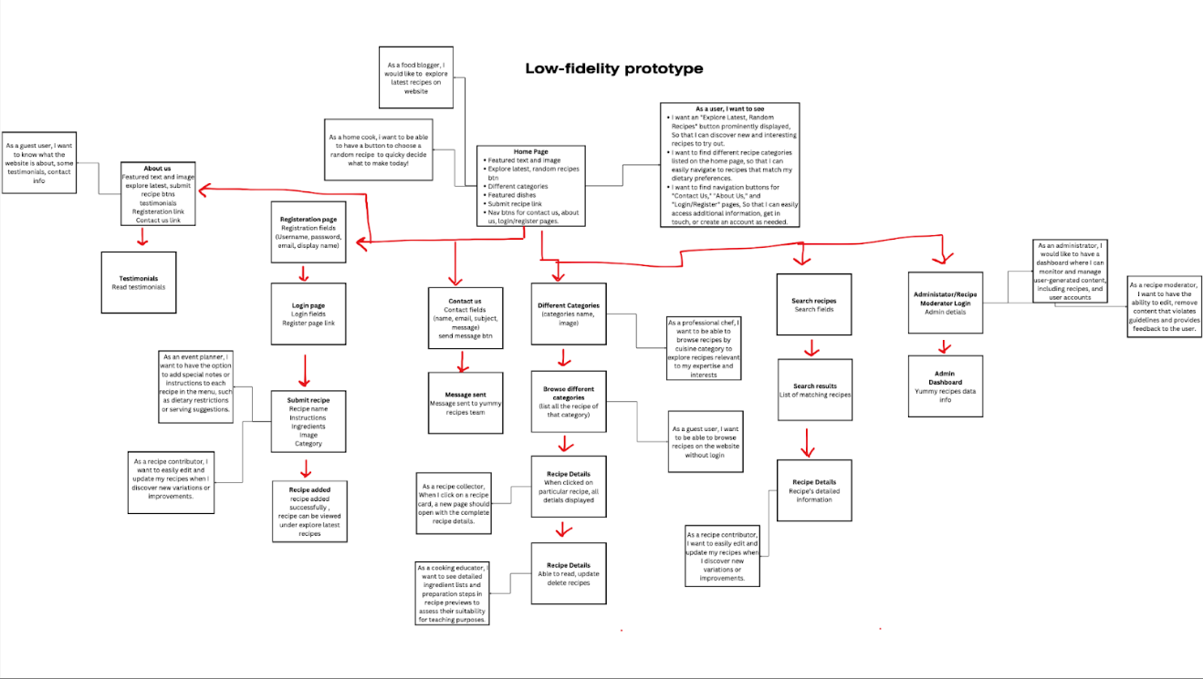

Figure 13: Low Fidelity Prototype

**Screenshots flowing through the system with full, written story in the figure caption:**

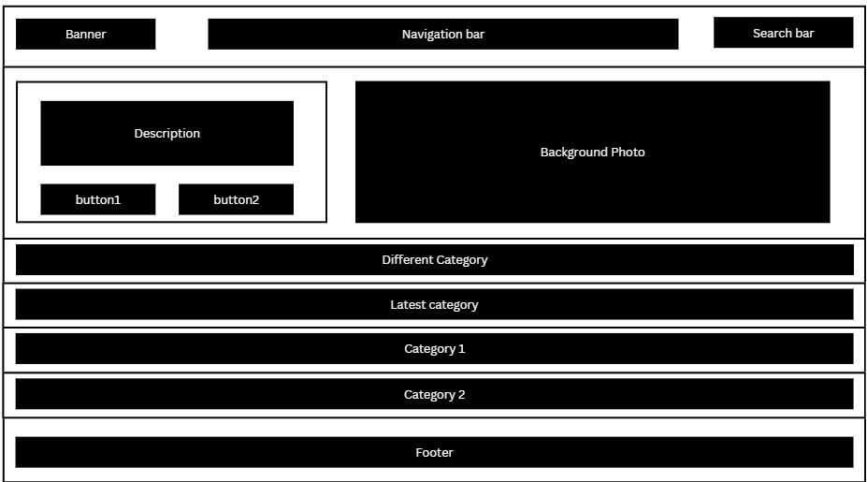

Figure 14: Home Page Wireframe

* Recipe Navigation: Users can easily browse recipes.
* Recipe Category Filters: Filter recipes by cuisine.
* Guest User Experience: Ensure guests can explore seamlessly.
* Basic Search: Provide a simple keyword-based recipe search feature.
* Guest User Access: Allow guests to view recipes without registering.
* Recipe Recommendations: Suggest similar recipes.
* Social Sharing Integration: Allow easy sharing on social media.
* Random Recipe Generator: Suggest random recipes.

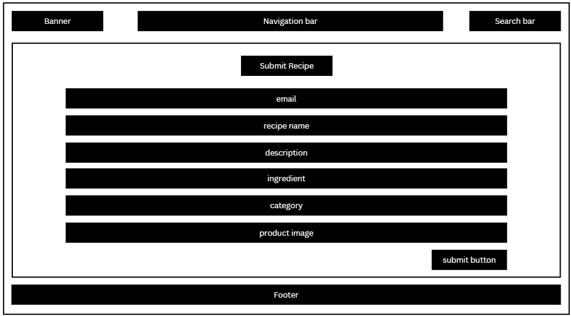

Figure 15: Submit Recipe Wireframe

* User Recipe Sharing: Enable users to share their recipes.

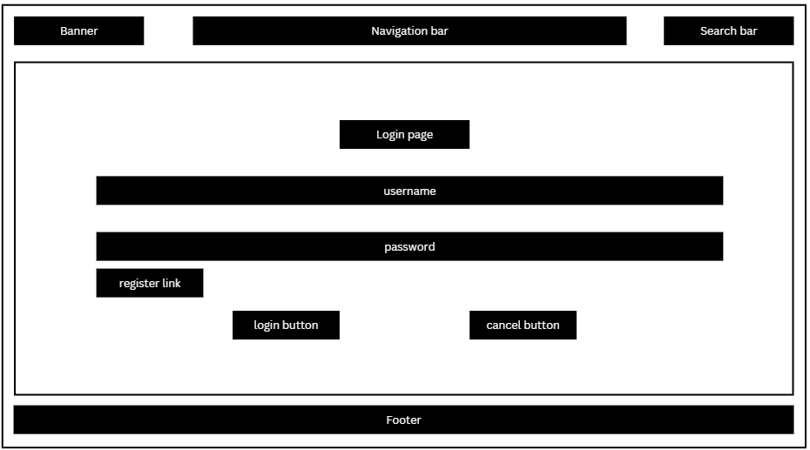

Figure 16: Login Page Wireframe

* User Account Management: Admin can handle user accounts.
* Admin Tools: Enhance content moderation and user management.
* Security Enhancements: Strengthen security measures.

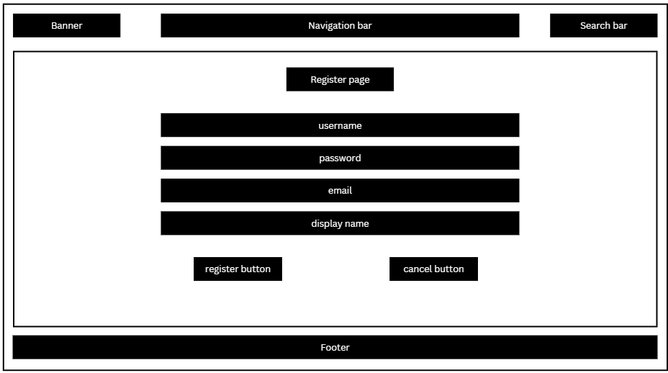

Figure 17: Registration Page Wireframe

* User Account Management: Admin can handle user accounts.
* Admin Tools: Enhance content moderation and user management.
* Security Enhancements: Strengthen security measures.

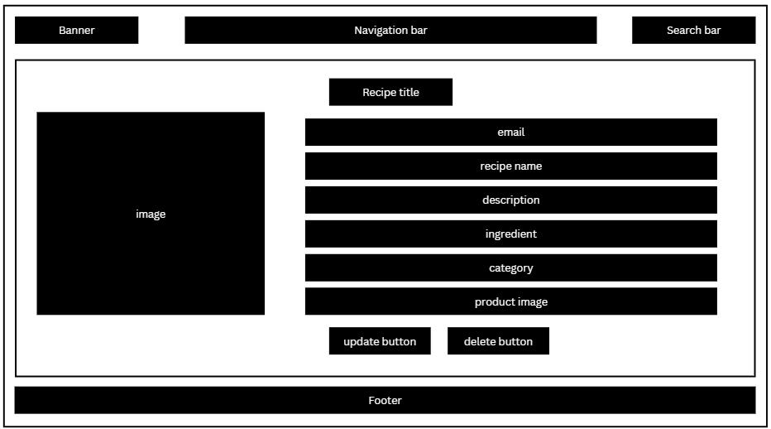

Figure 18: Recipe Details Page Wireframe

* Recipe Editing: Allow recipe contributors to edit recipes.

# APPENDIX B (TEST PLAN)

## 1.0 Introduction

### 1.0.1   Goals

The primary goal of this test plan is to ensure the thorough testing of Yummy Recipes. Specific testing objectives include:

* Verify the functionality of key features.
* Identify and rectify defects or issues within the application.
* Validate the application's performance under different conditions.
* Ensure compatibility with various platforms and environments.

### 1.0.2   Assumptions

The following assumptions are made for the execution of this test plan:

* The development team has implemented the features as per the provided specifications.
* The testing environment is set up with the necessary configurations.
* Test data and scenarios are representative of real-world usage.

### 1.0.3   Risks And Assets

### Risks:

1. Third-Party Dependencies: Dependencies on external services or libraries may impact the application's behavior.

2. Scalability: As user load increases, the application's scalability could pose a risk.

3. Data Security: Potential vulnerabilities in data security need to be thoroughly tested.

**Assets:**

1. Automated Testing Framework: The presence of an automated testing framework will expedite the testing process.

2. Test Data Sets: Well-prepared and diverse test data sets for comprehensive testing.

3. Collaborative Development: Active collaboration between development and testing teams to address issues effectively.

## 2.0 Scope

### 2.0.1   Features To Be Tested

**Functional Features**

1. **Explore Latest Recipes:**

1. Click "Explore Latest" button.
2. Expected outcome: Latest recipes displayed prominently on the homepage or in a designated section.

**2. Special Notes in a Recipe:**

1. Add special notes to a recipe.
2. View menu management system.
3. Expected outcome: Successfully added notes to a recipe. Special notes displayed alongside recipes in the event menu.

**3. Guest User Navigation:**

1. Explore "About Us" section.
2. View testimonials.
3. Expected outcome: Clear understanding of the website's mission and objectives. Gain confidence in the website's credibility and positive user experiences.

**4. Recipe Management:**

1. Log in as administrator or contributor.
2. Navigate to "Recipe Management" section.
3. Click on a user account or recipe card.
4. Expected outcome: Successfully access the dashboard. See a list of user-generated recipes and associated user accounts. Directed to the appropriate user account details or recipe editing page.

**5. View Complete Recipe Details:**

1. Click on a recipe card.
2. Scroll through recipe details.
3. Add the recipe to a personal collection.
4. Expected outcome: New page with complete recipe details. Easily read and understand the recipe. Recipe is added to the user's collection.

**6. Random Recipe Button:**

1. Click "Random Recipe" button.
2. View selected random recipe details.
3. Expected outcome: System displays a random recipe. Complete recipe with ingredients, instructions, and user comments.

**7. Recipe Editing and Updates:**

1. Log in as recipe contributor.
2. Navigate to "My Recipes" section.
3. Make necessary changes and update recipe.
4. Expected outcome: Successfully update and save the recipe.

**8. Admin Dashboard and Content Management:**

1. Log in with admin/moderator credentials.
2. View list of submitted recipes.
3. Click on "Manage User Accounts."
4. Expected outcome: Successfully access the dashboard. Options to approve, edit, or reject submitted recipes. Ability to view and take actions on user accounts, including suspension or promotion.

**9. Content Moderation and Feedback:**

1. Click on problematic recipe or content.
2. Provide feedback to the user.
3. Expected outcome: Clear communication about guideline violations and suggestions for improvement.

**10. Guest Browsing Without Registration:**

1. Click the website's "Home" button.
2. Use search functionality.
3. Expected outcome: Ability to view full recipe details without registration or login barriers. Perform searches and access search results without creating an account or logging in.

**11. In-Depth Recipe Previews for Teaching:**

1. Select a recipe from the curated list.
2. Click "View Full Recipe" button.
3. Expected outcome: Display preview with title, cuisine, and brief description. Thorough assessment of the recipe's suitability for teaching.

**12. Browse Recipes by Cuisine Category:**

1. Select "Browse by Cuisine" option.
2. Select a specific cuisine category.
3. Expected outcome: Page with curated list of recipes from the chosen cuisine. Explore detailed information about the selected recipe.

*Non-Functional Requirements*

***Performance Testing:***

* + Evaluate the application's response time under normal and peak load conditions.
  + Assess the system's stability and resource usage.

***Security Testing:***

* + Identify and rectify vulnerabilities related to data security.
  + Ensure secure data transmission and storage.

***Compatibility Testing:***

* + Verify the application's compatibility across different browsers, devices, and platforms.
  + Ensure functionality on various operating systems.

***Usability Testing:***

* + Evaluate the user interface for consistency, accessibility, and overall user experience.
  + Verify that the application adheres to design and accessibility guidelines.

***Scalability Testing:***

* + Assess the application's ability to scale with an increasing user base.
  + Identify potential bottlenecks in performance.

### 2.0.2    Features Not To Be Tested

Feature: Real-time Notifications

Reason:

Real-time notifications will not be tested in this phase due to time constraints and resource limitations. The primary focus of this testing phase is on core functionalities and ensuring a stable release. Real-time notifications involve intricate server-client interactions, and a comprehensive test for this feature requires a dedicated testing environment and extended testing timelines. Since it's not deemed critical for the initial release, it will be deferred to subsequent testing cycles. This decision is based on a risk assessment that considers the impact on the project schedule and the priority of other essential features.

Feature: In-Depth Recipe Previews for Teaching

Reason:

The In-Depth Recipe Previews for Teaching feature will not be tested in this phase due to its specialized nature and limited impact on core functionalities. The primary goal of this release is to ensure the seamless operation of fundamental user interactions and content management. Testing the in-depth preview feature involves assessing its suitability for educational purposes, which is beyond the immediate scope. This feature will be prioritized for testing in subsequent releases focused on enhancing educational aspects of the platform.

Feature: Browse by Cuisine Category

Reason:

The Browse by Cuisine Category feature will not be tested in this phase to streamline the testing process. While it offers an additional layer of user experience, the primary focus of this release is on basic navigation, recipe details, and content management. Comprehensive testing of the Browse by Cuisine Category feature requires evaluation across various cuisines, potential database impacts, and intricate UI interactions. This feature will be considered for testing in subsequent releases dedicated to enhancing the user's exploration of recipes by cuisine.

## 3.0 Testing Procedures

### 3.0.1   Test Objectives

**Functionality Testing:**

Objective: Ensure that all features and functionalities, such as recipe exploration, special notes, user navigation, and content management, work according to specified requirements and user expectations.

Criteria: The application should perform its intended functions without critical bugs or deviations.

**Security Testing:**

Objective: Validate the effectiveness of security measures in handling user-generated content.

Criteria: Sensitive data should be securely stored, and access controls must prevent unauthorized access to administrative features.

**Performance Testing:**

Objective: Assess the system's performance under varying loads to identify potential bottlenecks.

Criteria: The application should maintain responsiveness and stability, even during periods of peak usage.

**Compatibility Testing:**

Objective: Ensure the application works correctly across different browsers and devices.

Criteria: Consistent user experience and functionality should be maintained across major browsers (Chrome, Firefox, Safari) and devices (desktop, tablet, mobile).

**Usability Testing:**

Objective: Evaluate the overall user experience, focusing on navigation, readability, and intuitiveness.

Criteria: Users should be able to explore recipes, add special notes, and manage content with minimal confusion or difficulty.

**Regression Testing:**

Objective: Confirm that the introduction of new features or bug fixes does not negatively impact existing functionalities.

Criteria: All previously tested features should continue to operate correctly after implementing new changes.

**User Acceptance Testing (UAT):**

Objective: Gather feedback from end-users to ensure the application aligns with their expectations.

Criteria: Positive feedback from users regarding core functionalities and overall user experience.

### 3.0.2   Types Of Testing

The project will utilize various types of testing to ensure comprehensive quality assurance.

**3.0.2.1   Unit Testing**

For unit testing, each individual subsystem will be assessed independently to validate its correctness and functionality. The selection of subsystems for unit tests will be based on criticality and complexity, ensuring that each essential component undergoes rigorous testing.

#### 3.0.2.2   Integration Testing

Integration testing will focus on verifying the interfaces between subsystems. The strategy involves progressively combining subsystems, testing their interactions, and ensuring seamless integration. The order of integration will follow a logical sequence, with dependencies considered to guarantee smooth interactions between components.

**3.0.2.3   Acceptance Testing**

The acceptance testing strategy involves assessing the software's performance post-deployment. This phase includes evaluating the software's functions in the order specified by their importance. Test cases are not included in this section but will be detailed separately.

#### 3.0.2.4   Stress Testing

Stress testing will identify the operational limits under which the program is expected to perform. This includes assessing memory constraints, disk space limitations, and other factors that may impact the application's stability under stress conditions.

#### 3.0.2.5   Performance Testing

Performance testing will reference functional requirements that define acceptable performance levels. The objective is to ensure that the application meets or exceeds these requirements, guaranteeing optimal responsiveness and efficiency during regular usage.

### 3.0.3   Testing Tools

**Selenium**: Utilized for automated testing of web applications, ensuring accurate functionality across browsers.

**Jira**: Employed for comprehensive test management, issue tracking, and project management.

**JUnit**: Applied for Java unit testing to validate individual components and ensure code correctness.

**Postman**: Utilized for API testing, allowing efficient validation of backend functionalities.

**LoadRunner**: Employed for stress and performance testing, simulating various user loads to assess system behaviour under different conditions.

**TestRail**: Used for test case management and tracking, ensuring systematic organization and execution of test cases.

These tools collectively enhance the testing process, covering functional, performance, and integration aspects of the application.

## 4.0 Schedule and Deliverables

During the project lifecycle, various test deliverables will be generated to ensure thorough testing and comprehensive documentation. The following tables outline the schedule of tasks and the list of deliverables:

**4.1 Schedule of Tasks**

|  |  |  |
| --- | --- | --- |
| **Task** | **Start Date** | **End Date** |
| Acceptance Test | 2023-10-01 | 2023-10-15 |
| Unit Test | 2023-10-16 | 2023-11-01 |
| System/Integration Test | 2023-11-02 | 2023-11-15 |
| Stress Test | 2023-11-16 | 2023-11-31 |
| Performance Test | 2023-12-01 | 2023-12-15 |
| Screen Prototypes | 2023-12-16 | 2023-12-30 |
| Defect Reports and Summaries | 2024-01-01 | 2024-01-15 |
| Test Logs and Reports | 2024-01-16 | 2024-01-31 |

Table 22: Schedule of Tasks

**4.2 List of Deliverables**

|  |  |
| --- | --- |
| **Deliverable** | **Description** |
| Acceptance Test Report | Comprehensive report outlining results of acceptance tests |
| Unit Test Report | Detailed report on unit testing outcomes and coverage |
| System/Integration Test Report | Report summarizing results of system and integration tests |
| Stress Test Report | Documentation on system behavior under stress conditions |
| Performance Test Report | Report evaluating software performance against criteria |
| Screen Prototypes | Visual representations of application screens |
| Defect Reports and Summaries | Compilation of identified defects with resolutions |
| Test Logs and Reports | Records of test execution, issues, and overall status |

Table 23: List of Deliverables

Test Summary Report

The Test Summary Report provides a comprehensive view of the testing results for Release 1.0 of the project. This report covers various testing phases, including acceptance, unit, system/integration, stress, and performance testing.

The Test Summary Report provides a comprehensive view of the testing results for Release 1.x of the project. This report covers various testing phases, including acceptance, unit, system/integration, stress, and performance testing.

Key Metrics:

Total Number of Test Cases: 150

Number of Test Cases Executed: 145

Number of Test Cases Passed: 138

Number of Test Cases Failed: 7

Percentage of Test Cases Passed:

Overall Pass Rate: 95.17%

# APPENDIX C (END-USER & ADMINISTRATOR MANUALS)

**In this section, include a user manual for your system/application. The user manual should include the following items:**

1. **Instructions on how to install and configure your system/application, documenting all external software dependencies that need to be setup manually.**

Accessing Yummy Recipes - Quick Start Guide

Visit the Website:

To access Yummy Recipes, follow these simple steps:

Navigate to the Website:

Open your preferred web browser.

Enter the URL:

Type <https://yummmyrecipes.onrender.com/> in the address bar.

Access the Website:

Hit Enter to visit the website.

1. **A user guide for the administrator (use screen shots of your system/application and briefly discuss each screen shot).**

**Administrator Features - Coming Soon in Future Releases**

While the current version of Yummy Recipes focuses primarily on user-centric functionalities, we understand the importance of administrator features for effective content management. In upcoming releases, we plan to introduce dedicated sections for administrators, enabling efficient monitoring and management of user-generated content.

**Future Administrator Features:**

Content Review Dashboard:

* 1. Efficiently manage and moderate user-submitted content.
  2. Review, edit, or remove content that violates guidelines.
  3. Provide feedback to users for improvement.
  4. User Account Management:
  5. View and take actions on user accounts.
  6. Suspend or promote user accounts as needed.

**Administrator User Guide:**

A comprehensive user guide, complete with screenshots and detailed instructions, will be provided in future releases. This guide will walk administrators through each feature, ensuring a seamless experience in content moderation and user account management.

**Screenshots Coming Soon:**

While the current release does not include these administrator features, we value transparency and commitment to our users. Screenshots illustrating the administrator interface will be added in subsequent releases, giving administrators a preview of the powerful tools at their disposal.

**Stay Tuned for Updates:**

We are actively working on enhancing Yummy Recipes to cater to both user and administrator needs. Stay tuned for exciting updates and improved functionalities in the near future.

1. **A user guide for the normal user (use screen shots of your system/application and briefly discuss each screen shot).**

**Yummy Recipes User Guide**

Welcome to Yummy Recipes! This guide will help you navigate through the key features of our application. Let's get started:

**Homepage**

Figure 19: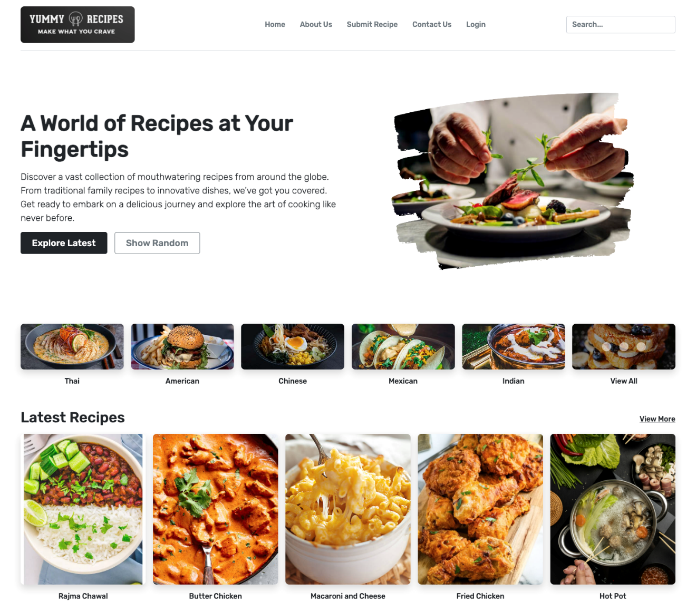 Homepage Screenshot 1

Figure 20: Homepage Screenshot 2

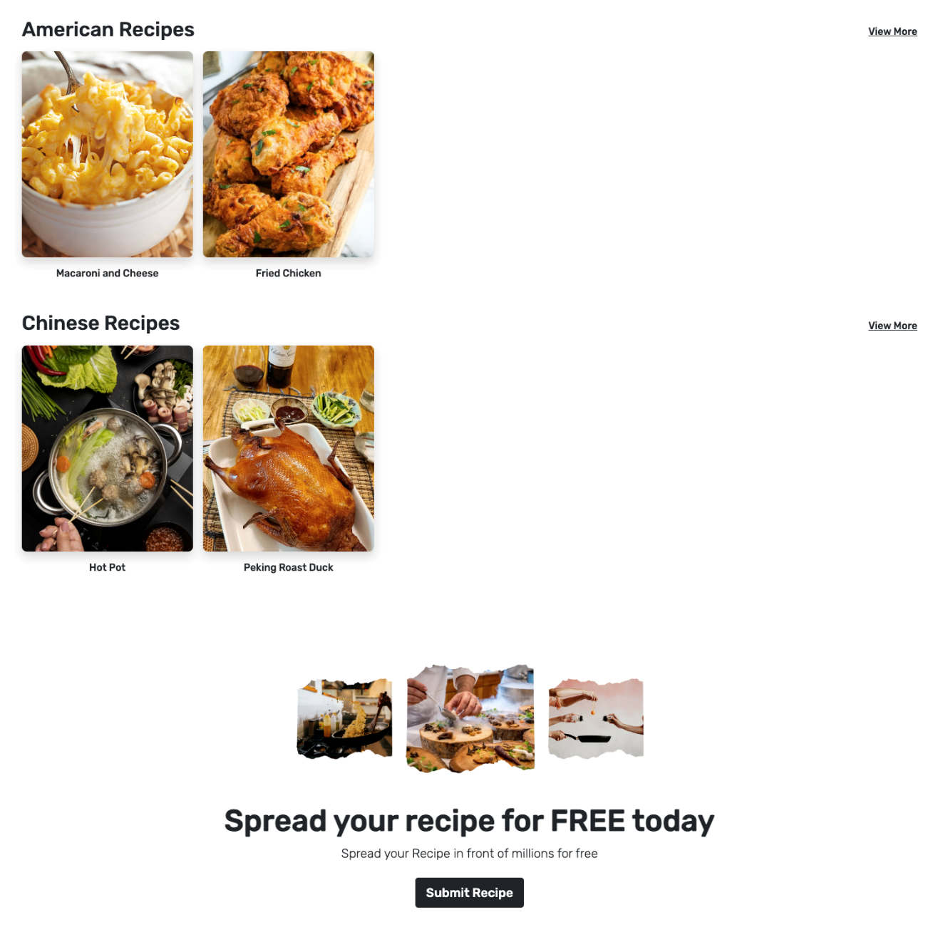Welcome to the homepage of Yummy Recipes! This guide will help you navigate and explore the exciting features available:

**Explore Latest:**

Click on the "Explore Latest" button to discover the newest and trending recipes on the platform.

**Show Random:**

Feeling adventurous? Hit the "Show Random" button for a surprise recipe selection.

**Cuisine Categories:**

Explore recipes by choosing from a variety of cuisine categories.

Click on your preferred cuisine to discover delightful recipes.

**Latest Recipes:**

Find the most recent and popular recipes showcased in the horizontal section at the top.

**Categorized Recipes:**

Explore diverse cuisines with the horizontally listed recipes below.

Click on each category to view more recipes of that type.

**Submit Your Recipe:**

Have a special recipe to share? Click on the link at the end of the page to submit your own recipe.

Share your culinary creations with the Yummy Recipes community!

**About us Page**

Figure 21: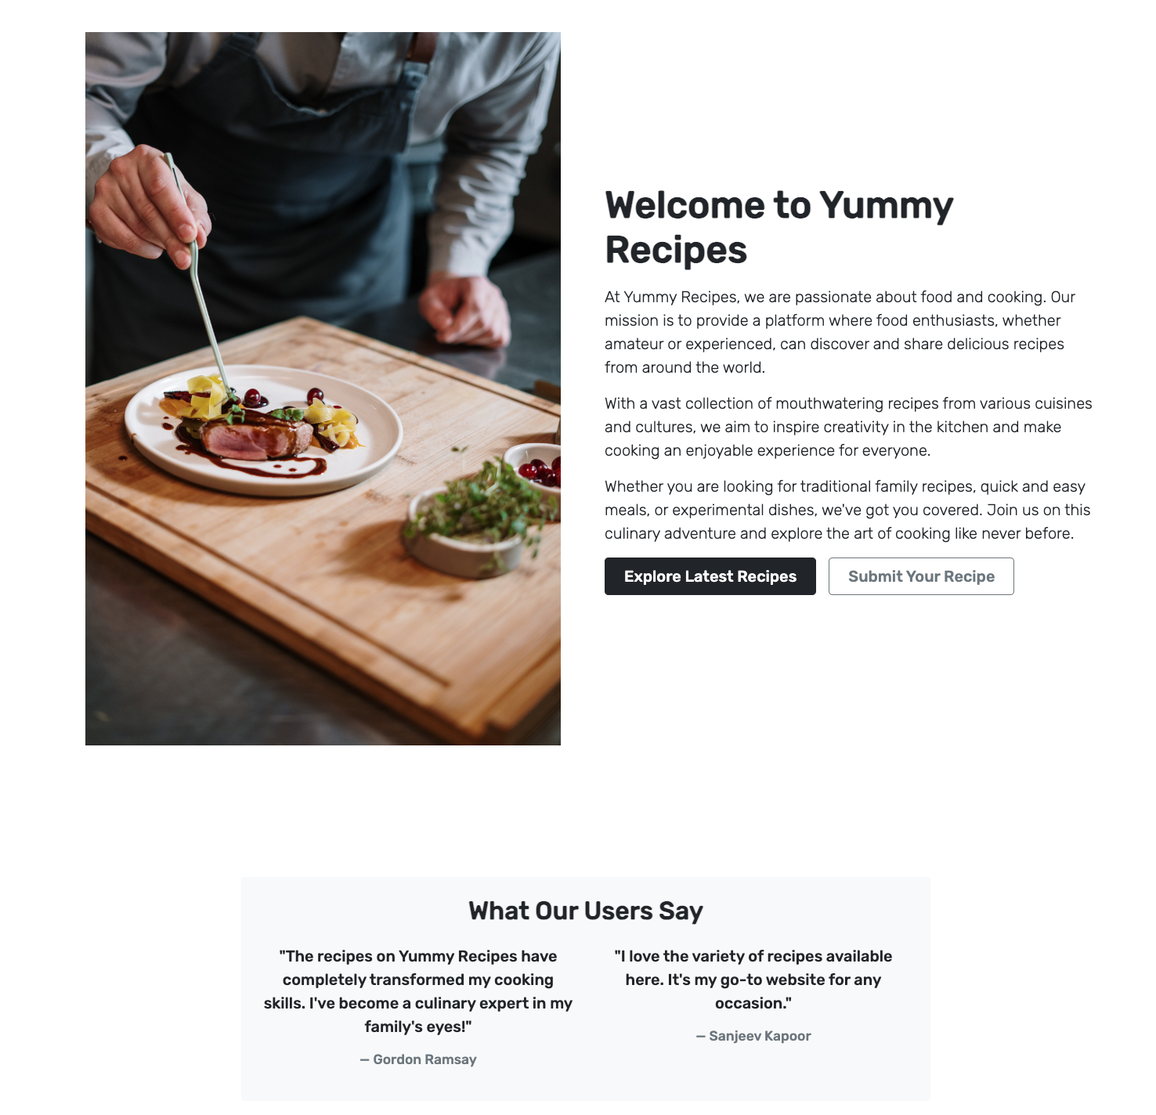 About Us Page Screenshot 1

**About Us User Guide**

Welcome to our "About Us" section! Here, you'll find everything you need to know about our platform and how to engage with us. Let's walk through the key elements:

**About Us Text and Image:**

Learn about our journey, mission, and the people behind this platform.

Explore the vibrant visuals that tell our story.

**Explore Latest:**

Click on the "Explore Latest" button to dive into the newest and most exciting recipes.

**Submit Your Recipe:**

Ready to share your culinary masterpiece? Hit the "Submit Recipe" button and become part of our community.

**Testimonials**:

Discover what others are saying about their experiences.

Figure 22: About Us Page Screenshot 2

**Join Now:**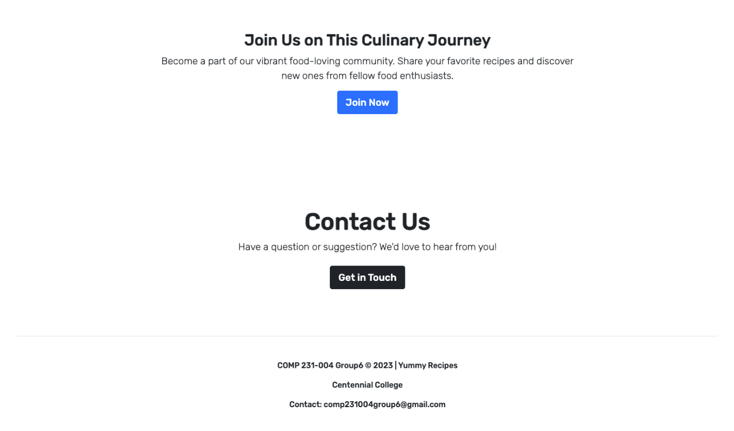

Ready to join our community? Simply hit the "Join Now" button and be a part of something extraordinary.

**Contact Us:**

Have questions or suggestions? The "Contact Us" section is here for you.

Click on the "Contact Us" button to reach out to our team.

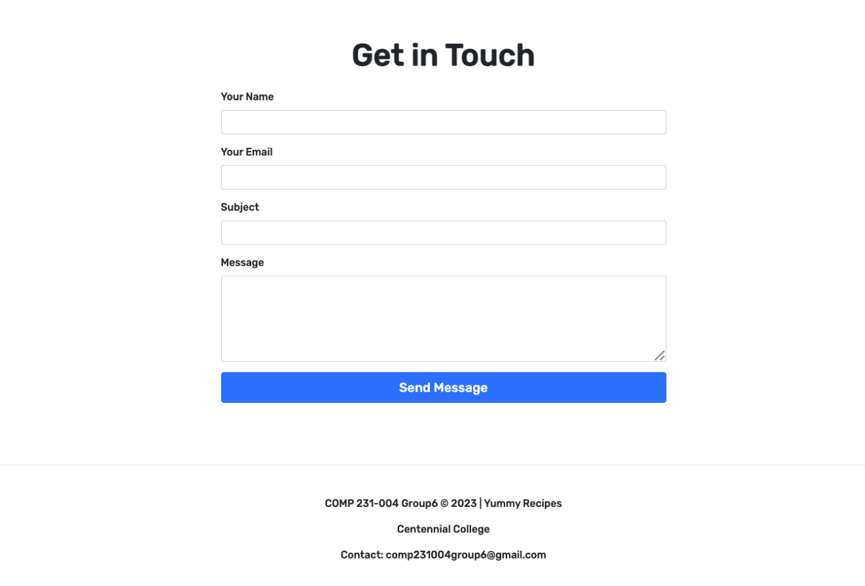**Contact Us Page:**

Figure 23: Contact Us Page Screenshot

Welcome to our "Contact Us" page! If you have questions, suggestions, or just want to say hello, you're in the right place.

**How to Use:**

Fill out the simple form with your name, email, and your message.

Click the "Submit" button to send your message to the Yummy Recipes team.

Expect a prompt response from our team. Your feedback matters!

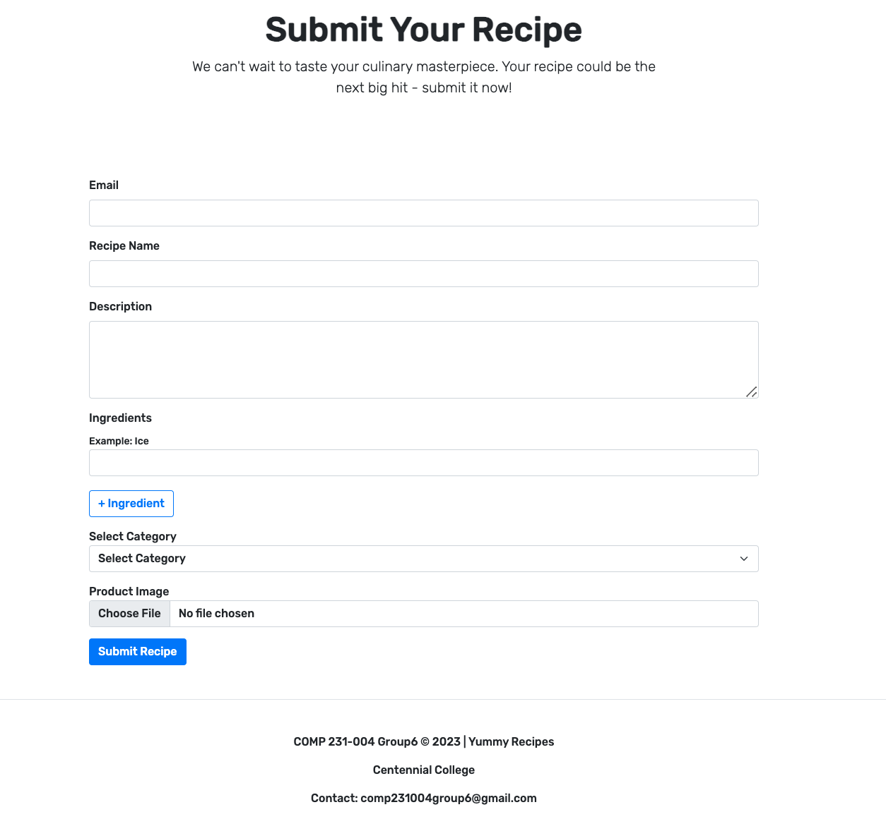**Submit Recipe Page:**

Figure 24: Submit Recipe Page Screenshot

Ready to share your culinary masterpiece? Here's how you can submit a recipe:

**How to Use:**

If you're logged in, you can directly submit your recipe.

If not, you'll be prompted to log in or register.

Follow the steps to add your recipe details, ingredients, and instructions.

Click "Submit," and voila! Your recipe is on its way to becoming a Yummy Recipes sensation.:

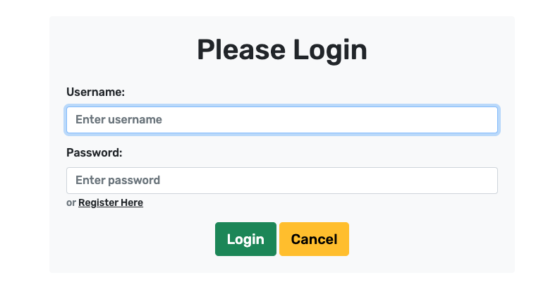**Login and Register Pages:**

Figure 25: Login Page Screenshot

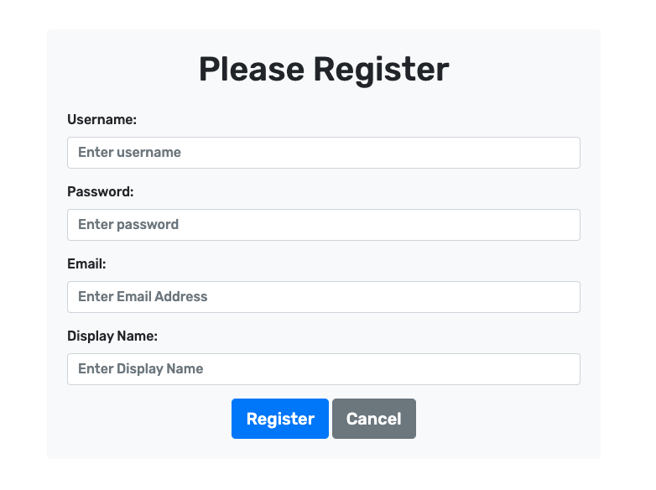

Figure 26: Register Page Screenshot

Unlock the full potential of Yummy Recipes by logging in or registering:

**How to Use:**

Click on "Login" if you already have an account.

If not, click on "Register" to create a new account.

Fill in the required details.

Access exclusive features and personalized content by logging in.

**Search Box in the Navbar:**

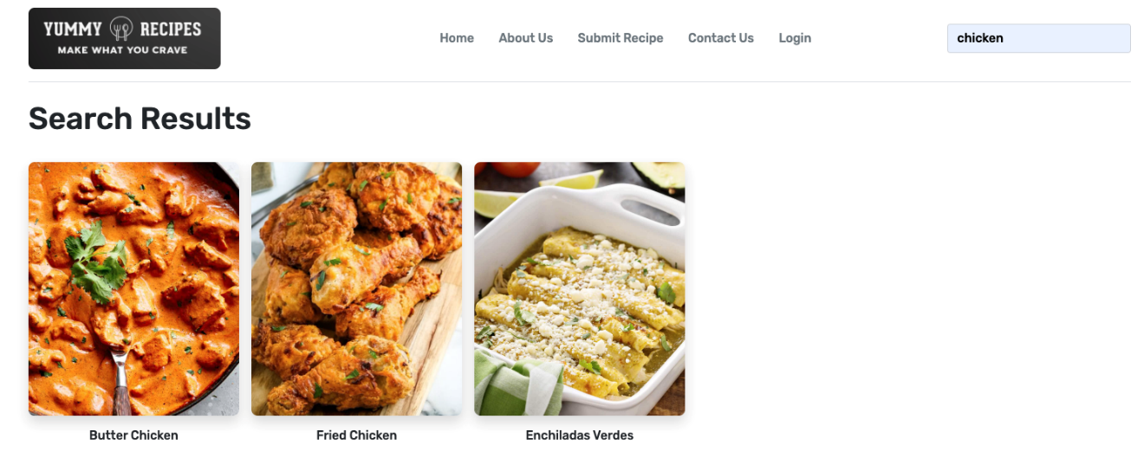Figure 27: Search Results Screenshot

Looking for something specific? Our search box makes it easy!

**How to Use:**

Type your query in the search box.

Hit "Enter" or click the magnifying glass icon.

Explore relevant recipes and content tailored to your search.

**Recipe Details Page:**

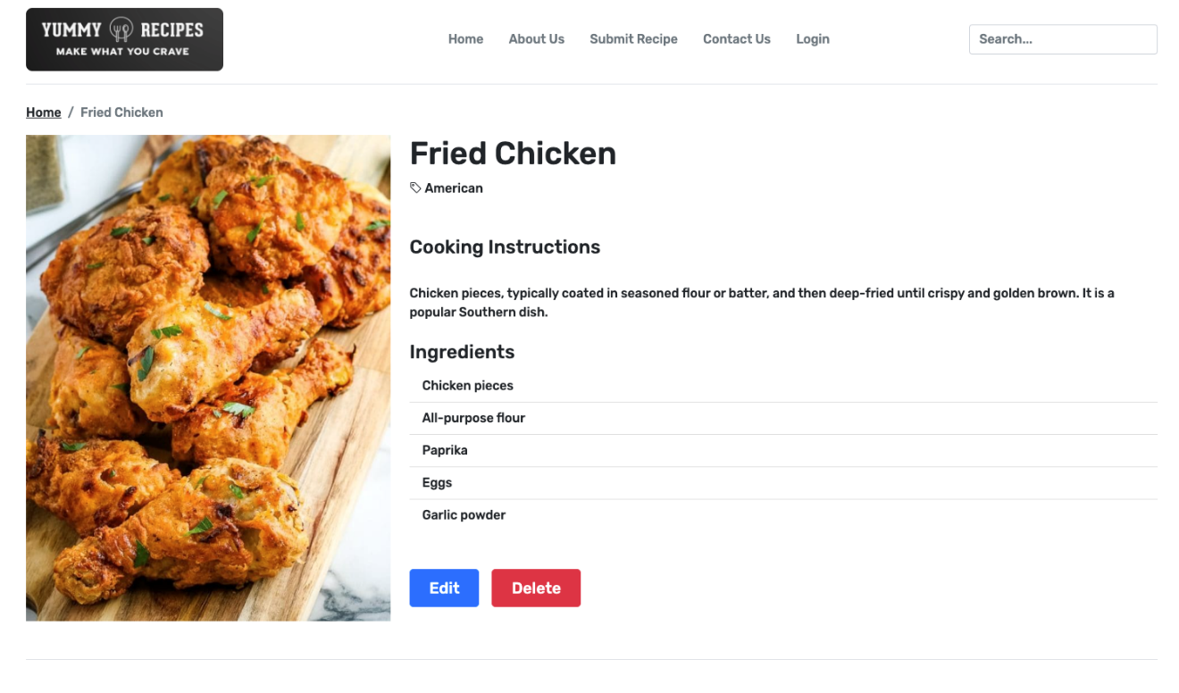

Figure 28: Recipe Details Page Screenshot

Explore the details of your favorite recipes:

How to Use:

Click on any recipe to open its details page.

Find a comprehensive overview, including ingredients and instructions.

If logged in, you'll see options to edit or delete the recipe.

Enjoy your culinary journey with Yummy Recipes!

We hope you enjoy using Yummy Recipes ! If you have any questions or need assistance, feel free to contact our support team.

Happy cooking! 🍳🌮🍰

# APPENDIX D (PROGRESS MONITORING)

|  |  |  |
| --- | --- | --- |
|  | Iteration 1 | Iteration 2 |
| Story Points at start of iteration | 71 | 105 |
| Completed during iteration | 56 | 85 |
| Changed estimates | 14 | 21 |
| Story Points from new stories | 76 | 0 |
| Story Points at end of iteration | 105 | 41 |

Table 24: Progress Monitoring

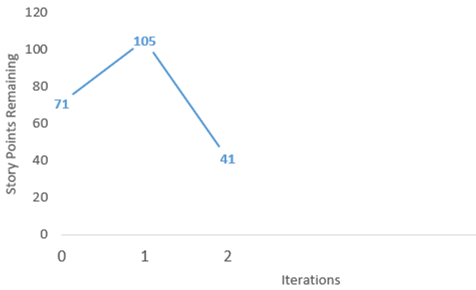

##### Figure 29: Iteration 2 Burndown Chart